**192110326**

**B.Himanth Sai**

**17. Change Hardware compatibility of a VM (Either by clone/create new one) which is already created and configured.**

Unchanged Hardware:

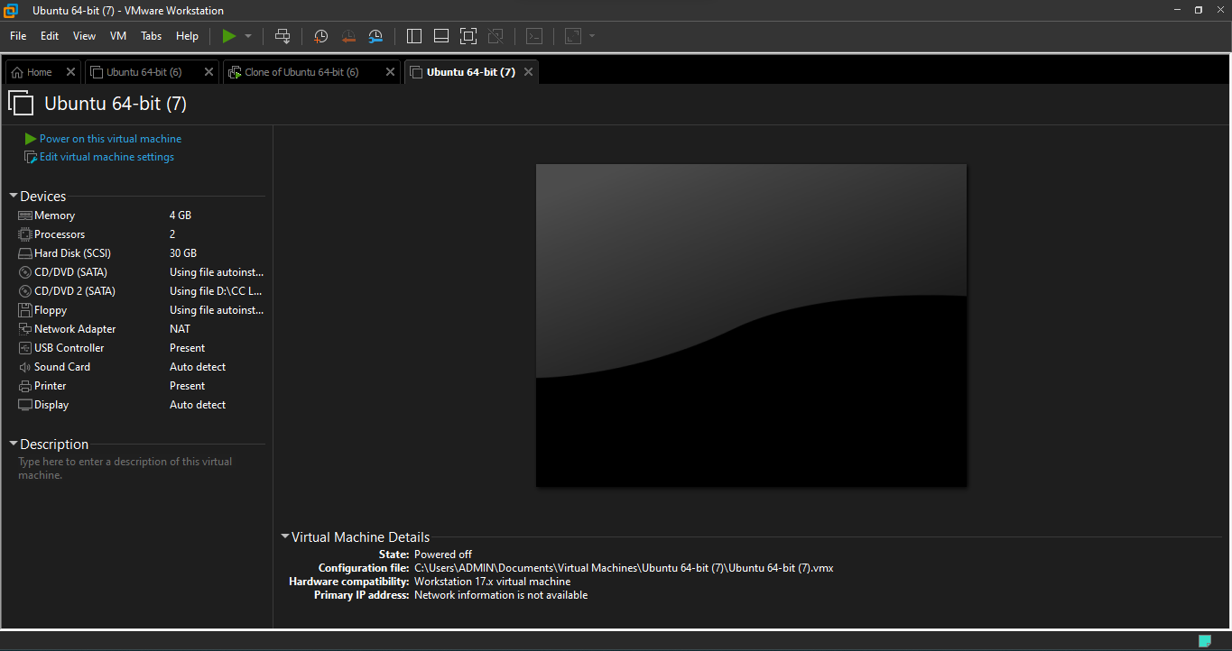

Changed Hardware:

